People Analytics

Project Report

at the Faculty of Business, Economics, and Law

Friedrich-Alexander-Universität Erlangen-Nürnberg

Schöller Endowed Chair for Information Systems

Prof. Dr. Sven Laumer

Presented by: Md Abdullah Al Mahmud Khosru

Hauptstrasse 91

Erlangen, 91054

+49 15754650982

md.khosru@fau.de

23070520

Final Date of Submission: 2025-01-26

# Content

Content 2

1 Well-Being 3

1.1 The importance of well-being *(4 Points)* 3

1.2 Stress induced by technology *(7 Points)* 4

1.3 Employee well-being dataset *(8 Points)* 5

1.4 Predictive well-being algorithm *(6 Points)* 9

2 Turnover 12

2.1 Employee Turnover *(4 Points)* 12

2.2 Employee Turnover Theories *(6 Points)* 13

2.3 Employee Turnover Dataset *(10 Points)* 14

2.4 Turnover prediction *(5 Points)* 17

References VII

Declaration of Academic Integrity at the Schöller Endowed Chair for Information Systems VIII

# Well-Being

## The importance of well-being *(4 Points)*

First and foremost, Monitoring employee well-being is very essential for organizations like FAU Clinic, as it significantly influences employee performance, engagement, and productivity. Employees who experience a positive work environment are more motivated, efficient, and likely to contribute to organizational success. Conversely, poor well-being can lead to absenteeism, burnout, and high turnover rates, ultimately increasing healthcare costs and impacting the overall workplace culture. A healthy workforce fosters higher productivity while reducing costs related to health insurance and sick leave. Furthermore, prioritizing well-being creates a supportive culture that enhances employee morale, loyalty, and retention, making the organization attractive to top talent.

Several factors contribute to low levels of employee well-being and an unhealthy work-life balance. Excessive workloads, long hours, and performance pressure often result in burnout and chronic stress. Lack of control over work and unclear job roles exacerbate dissatisfaction, while insufficient support from colleagues and supervisors can lead to feelings of isolation. Technostress—caused by rapid technological changes, system breakdowns, and high reliance on ICT—can also negatively affect well-being, inducing overload and uncertainty. Additionally, conflicts between work and family commitments disrupt personal lives, straining mental and emotional health.

To monitor employee well-being effectively, FAU Clinic could employ a multifaceted approach. Regular surveys and focus groups can collect valuable data on employee perceptions of their well-being. Data-driven technologies like well-being analytics can analyze key indicators such as absenteeism, turnover rates, and performance metrics to identify trends and areas for improvement. Implementing health and wellness programs, such as fitness challenges, stress management workshops, and mental health support, can enhance both physical and emotional well-being. Offering flexible working hours, job autonomy, and clear role definitions can also help employees maintain a healthy work-life balance. Establishing continuous feedback mechanisms ensures employees feel heard and supported, fostering a culture of trust and inclusivity.

## Stress induced by technology *(7 Points)*

Introducing a new Electronic Health Record (EHR) system at FAU Clinic could significantly influence employees' stress levels, particularly due to the phenomenon of technostress. Technostress arises when employees face challenges in adapting to new technologies, such as unfamiliar interfaces, technical glitches, or the rapid pace of technological change. This stress may manifest in two ways: **techno-distress**, where employees perceive the new system as overwhelming, and **techno-overload**, where they feel pressured to work faster or handle more tasks due to increased digital demands. Additionally, issues like system complexity, unclear instructions, or inadequate training can lead to **techno-complexity** and **techno-uncertainty**, further exacerbating stress. For FAU Clinic, these factors could result in decreased job satisfaction, lower morale, and resistance to adoption, which in turn might lead to productivity losses, errors in patient care, and increased turnover.

The consequences of such stress are not limited to workplace outcomes; they may also affect employees' mental and physical health, causing burnout, anxiety, and fatigue. These outcomes can elevate organizational costs due to absenteeism, higher health insurance claims, and the need to recruit and train new employees. Furthermore, staff dissatisfaction with the system could undermine the benefits the clinic hoped to achieve with the upgrade, reducing the return on investment.

To mitigate these challenges, FAU Clinic should adopt proactive measures to support its staff during the transition. Comprehensive and user-centered training programs are crucial to ensuring employees feel confident and capable of using the new system. A phased implementation approach, allowing employees to gradually adapt to the technology, can reduce feelings of being overwhelmed. The clinic should provide ongoing technical support to address issues promptly and minimize frustration. Encouraging open communication and feedback will help employees voice their concerns and feel supported throughout the process. Additionally, promoting a culture that recognizes and rewards adaptability can increase acceptance of the new technology. Providing wellness programs, such as stress management workshops or access to mental health resources, can also help employees manage their stress effectively.

A few general recommendations include conducting a **needs assessment** to align the new EHR system with employees' workflows, minimizing **techno-complexity**. Providing tailored **training programs** can build confidence, while empowering **tech-savvy employees as system champions** can offer peer support. Clear **communication about the timeline and updates** reduces **techno-uncertainty**, and **feedback mechanisms** allow employees to voice concerns and suggest improvements. Temporary workload adjustments during the transition can alleviate **techno-overload**, supporting work-life balance. Finally, using **well-being analytics** to monitor stress indicators like absenteeism ensures proactive issue resolution and smooth adoption of the new system.

## Employee well-being dataset *(8 Points)*

At first I read the dataset using pandas and then check for null values.





The converted the job age and gender column into numeric values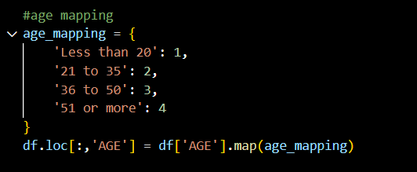

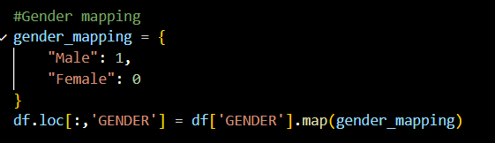

As we got invalid values to DAILY_STRESS column, let’s 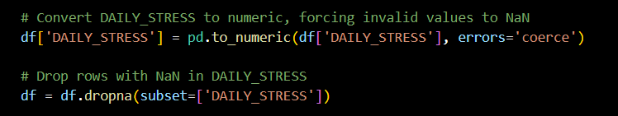deop it.

Now our data is ready for analysis.

Daily stress by Gender:

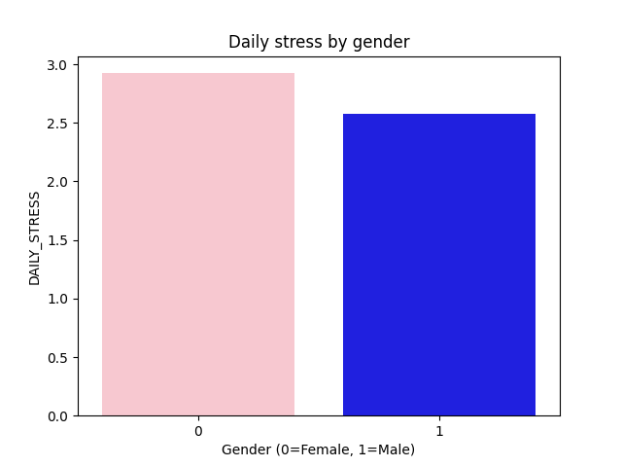

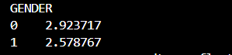

This bar chart shows the average daily stress levels by gender, where 0 represents females and 1 represents males. The results indicate that females (2.923717) experience slightly higher daily stress levels compared to males (2.578767).

Daily stress by Age: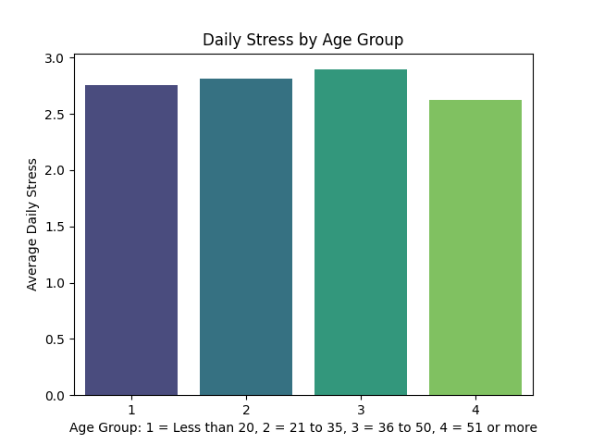

This bar chart illustrates the average daily stress levels across different age groups. Individuals aged 36 to 50 (group 3) report the highest stress levels, followed closely by those aged 21 to 35 (group 2). Stress levels tend to decrease slightly in older age groups, particularly for individuals aged 51 and above (group 4).

who dedicates more time to their hobbies, men or women:

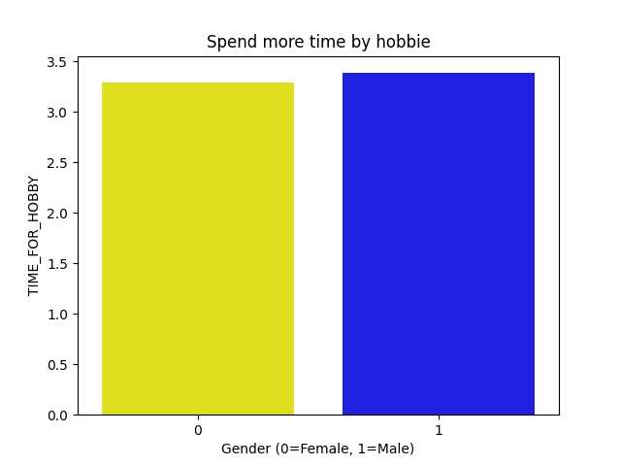

From the chart, men (gender = 1) dedicate slightly more time to their hobbies compared to women (gender = 0). This is evident from the slightly higher bar for men in the chart.

correlation matrix:

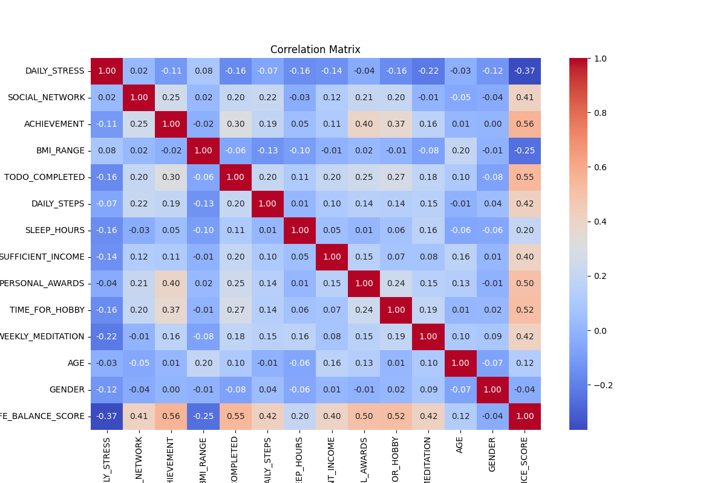

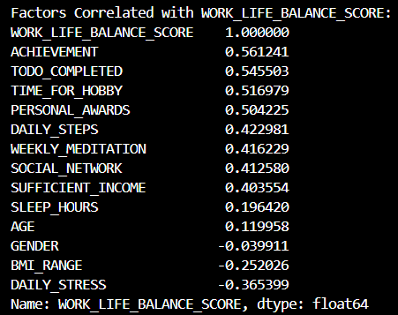

So, we can say **Achievement** is highly correlated to the Work-Life Balance (WLB) score, followed by To-do Completed, Time for Hobby, Personal Awards, and so on.

## Predictive well-being algorithm *(6 Points)*

­For the prediction I used Linear regression model and found the r2 score is 0.853

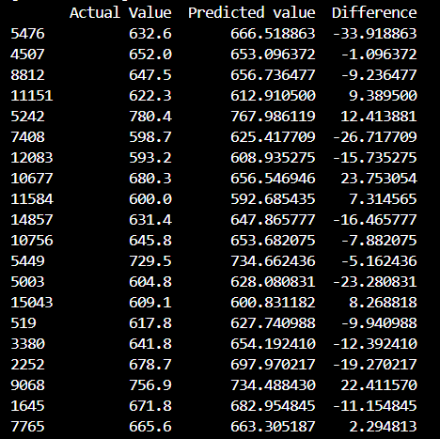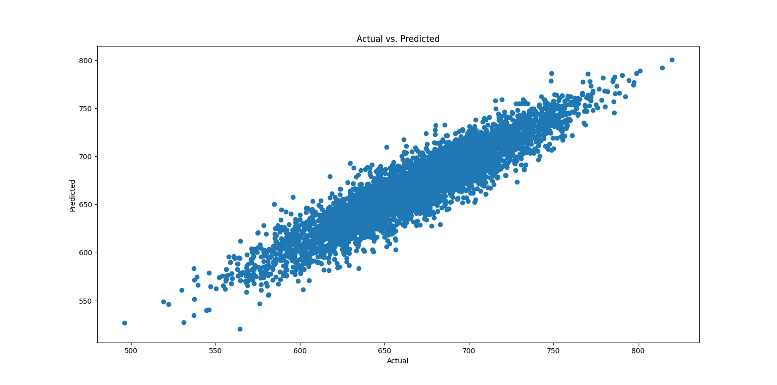Here is the chart for real value and the predictive values:

Here is a new record of a employee and the result is:

Let’s have a look at the 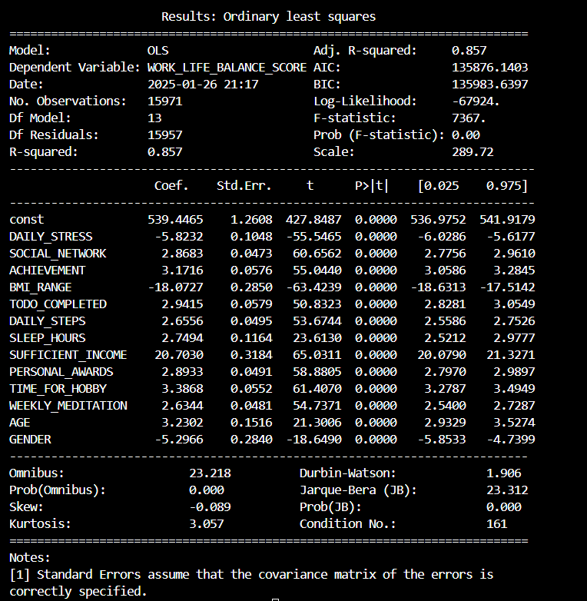summary:

FAU Clinic can take several steps to improve employees' Work-Life Balance (WLB) scores. Reducing daily stress is essential and can be achieved through stress management programs, wellness workshops, and flexible work schedules. Encouraging social networking through team-building activities and fostering a supportive environment can enhance workplace relationships. Promoting achievement opportunities, such as career development paths and recognition programs, can boost employees’ sense of accomplishment. Additionally, supporting hobbies and leisure activities by offering flexible hours or wellness days and encouraging physical activity through fitness programs can improve overall well-being. These measures will help create a balanced and satisfied workforce.

# Turnover

## Employee Turnover *(4 Points)*

Voluntary employee turnover refers to a situation where employees decide to leave an organization on their own, rather than being terminated by the employer. This phenomenon is of significant concern to organizations like FAU Clinic, where turnover rates have reached alarming levels. High turnover is worrisome due to the associated costs, which can range from 30% to 400% of the departing employee’s annual salary. These costs stem from recruitment, onboarding, and the time required for new hires to reach optimal productivity. Additionally, turnover leads to the loss of institutional knowledge, disrupts operations, lowers morale among remaining staff, and could harm the organization’s reputation if it reflects systemic issues.

**The Organization Equilibrium Theory**, proposed by March and Simon (1958), offers insights into why employees quit. It posits that turnover occurs when individuals perceive an imbalance between their contributions to the organization and the incentives they receive. Dissatisfaction with job roles, inadequate recognition, limited career development opportunities, and poor management are common triggers for turnover. Employees who feel undervalued or unfulfilled are more likely to seek employment elsewhere.

Another factor influencing turnover is the ease of movement, which is facilitated by a thriving job market. When alternative opportunities are readily available, employees find it easier to secure positions that align better with their values, goals, and career aspirations. Factors such as lack of career progression, poor work-life balance, inadequate compensation, and misaligned cultural fit further contribute to turnover, creating a situation where employees feel compelled to leave.

**To address this challenge**, FAU Clinic must adopt data-driven approaches to identify the root causes of turnover and implement targeted solutions. These could include fostering supportive leadership, improving career pathways, enhancing workplace culture, and ensuring competitive compensation and benefits. By addressing these factors, FAU Clinic can retain employees and strengthen organizational stability while mitigating the costly effects of turnover.

## Employee Turnover Theories *(6 Points)*

**Case 1: Sarah**

Sarah aligns with FAU Clinic’s focus on patient care but feels disconnected due to a lack of strong social connections and meaningful relationships with her colleagues. According to the **Job Embeddedness Theory**, employees are more likely to stay in their jobs when they feel connected to their coworkers (links), fit well within the organization, and perceive significant sacrifices in leaving. Sarah’s low level of social connections reduces her job embeddedness, making it easier for her to consider quitting.

To retain employees like Sarah, FAU Clinic can focus on building stronger social connections within the workplace. Firstly, they can encourage team-building activities and social events to help employees bond and form meaningful relationships. Secondly, introducing mentorship programs can help new employees like Sarah integrate, feel comfortable, and connect with their colleagues. Finally, creating support networks or employee well-being groups focusing on social integration can foster a sense of belonging and improve job embeddedness.

**Case 2: Emily**

Emily left FAU Clinic after the practice she worked for was acquired by the clinic. The transition from a small, collaborative healthcare setting to a large, hierarchical organization conflicted with her values of independence and autonomy. This aligns with the **Unfolding Model of Turnover**, which explains that significant events or shocks, like the acquisition, lead employees to reassess their jobs and consider leaving if the new situation misaligns with their personal values or career goals. For Emily, this shock resulted in dissatisfaction with the new corporate culture and ultimately led her to resign.

To manage turnover in such situations, FAU Clinic can develop strategies to retain employees during organizational transitions. First, they should focus on integrating the culture of acquired practices while preserving elements that employees value, such as collaboration and autonomy. Second, transparent communication during transitions can reduce employee anxiety and ensure they feel included in the process. Lastly, providing opportunities for employees to maintain some level of independence and keeping aspects of their original work environment intact can help ease the transition and improve retention. By understanding and applying these strategies, FAU Clinic can better manage turnover and retain key talent.

## Employee Turnover Dataset *(10 Points)*

First, load the dataset using pandas: df = pd.read_csv('fau_clinic_turnover_data.csv') and then go forward to answer all the questions. Let’s explore the answer below:

How does job satisfaction vary by job role?

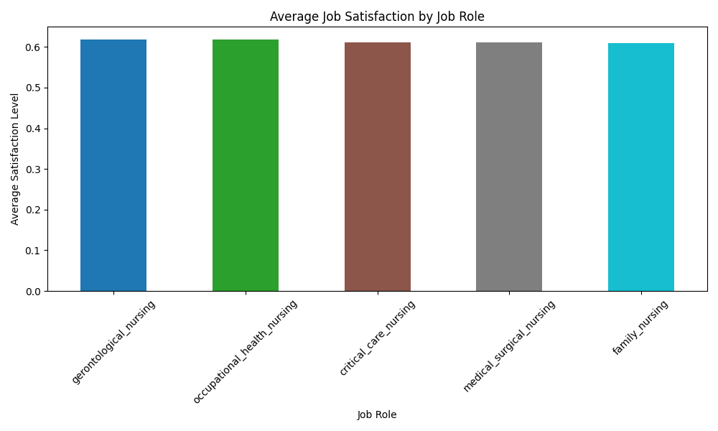

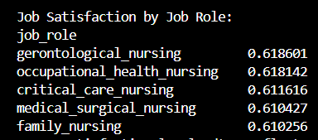The average job satisfaction varies slightly among different job roles at FAU Clinic. Employees in **gerontological nursing** and **occupational health nursing** report the highest satisfaction levels (0.618), while those in **family nursing** have the lowest satisfaction levels (0.610). This indicates relatively uniform but slightly differing satisfaction levels across roles

How does salary vary by job role?

The salary distribution varies slightly across job roles, with most employees earning **low to medium salaries**. High salaries are the least common.

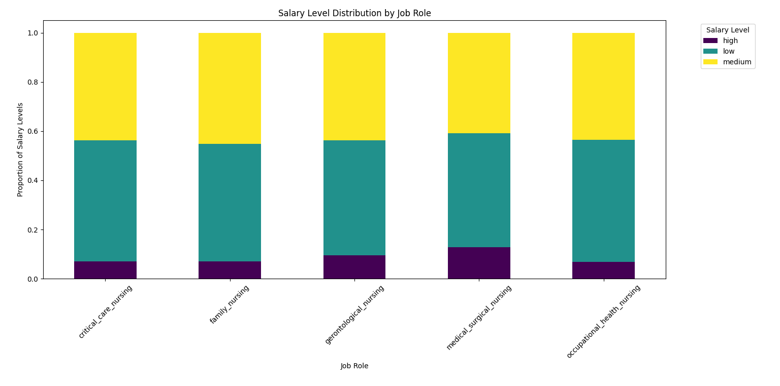

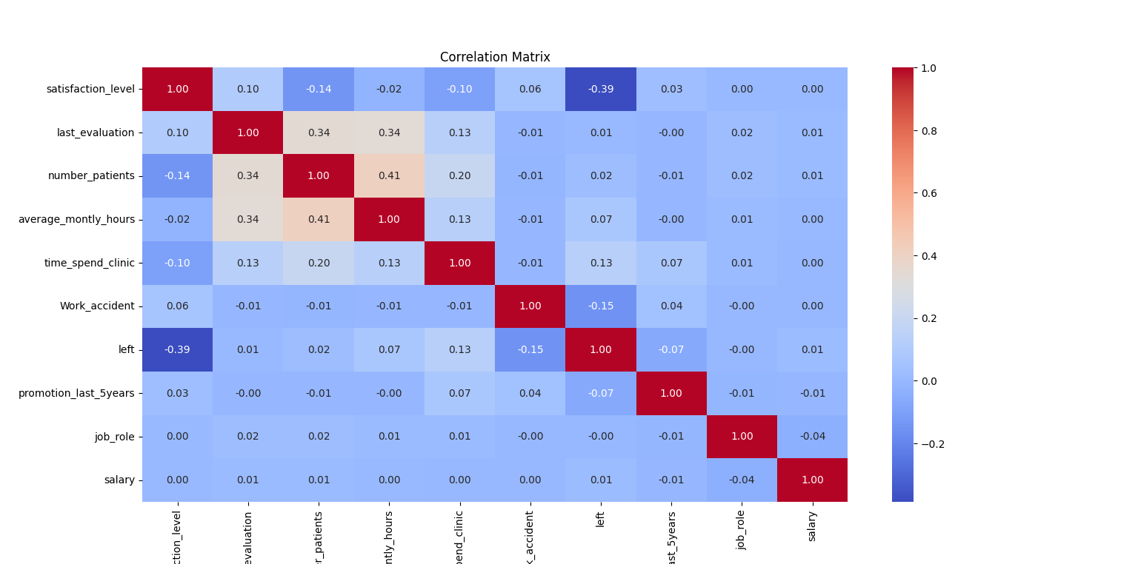correlation matrix:

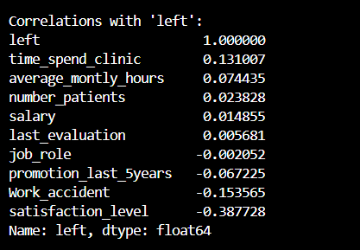

* **Highly Negative Correlation**: **Satisfaction Level (-0.39)**: Employees with lower satisfaction levels are more likely to leave, making it the strongest negative correlation with the left column.
* **Slightly Negative Correlation**: **Work Accident (-0.15)**: Employees who experience fewer workplace accidents are slightly more likely to leave, though the correlation is weak.

**Positive Correlations**: No strong positive correlations are observed with the left column in this dataset.

Average job satisfaction level of employees who left FAU Clinic:

The average job satisfaction level of **0.44** indicates that, on a scale of **0 to 1** (assuming satisfaction levels are normalized in the dataset), employees who left FAU Clinic reported **low satisfaction** with their jobs.

The average time spent at FAU Clinic by employees who left:

This indicates that employees who leave typically remain with the organization for nearly four years before deciding to terminate their contracts. This timeframe suggests a potential pattern where dissatisfaction, stagnation, or unmet expectations may develop over time.

Now let’s check for any missing values:

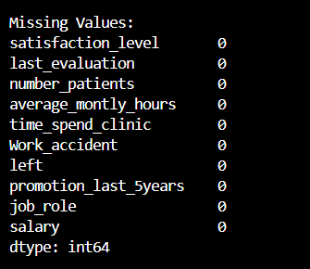No missing values were found.

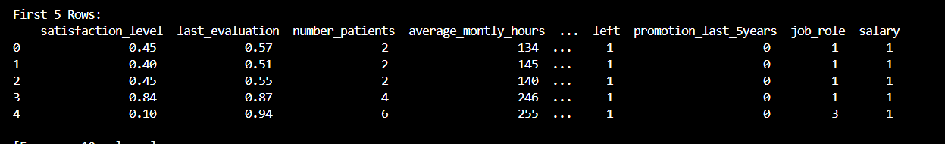Now Convert categorical columns to numeric as we have job_role and salary: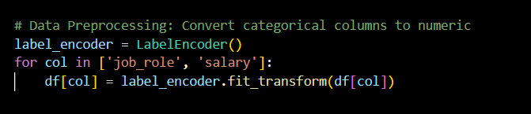

I think there’s a high correlation between two columns (e.g., number_patients and average_montly_hours), for this reason I combined a new feature and named them as patients_hours_combined.

## Turnover prediction *(5 Points)*

For predicting employee turnover at FAU Clinic, I used the **Random Forest Algorithm**

Random Forest is an excellent choice for turnover prediction due to its ability to manage complex datasets with multiple interconnected factors. By building a multitude of decision trees and averaging their predictions, it captures these intricate relationships with high precision. This process ensures robust performance while minimizing the risk of overfitting, even when applied to new, unseen data.

Additionally, Random Forest offers valuable insights into the importance of various features influencing employee turnover. This makes it not only a predictive tool but also an analytical one, helping identify key factors driving employees to leave. Furthermore, its scalability and efficiency enable it to handle large datasets with numerous features, making it ideal for FAU Clinic's dataset, which includes both numerical and categorical data. Random Forest also effectively processes missing values and outliers, ensuring reliable results.

With its strong track record across various domains, Random Forest is recognized for its accuracy, dependability, and interpretability, making it a robust tool for understanding and addressing employee turnover at FAU Clinic.

Let’s discuss for the performance of the model:

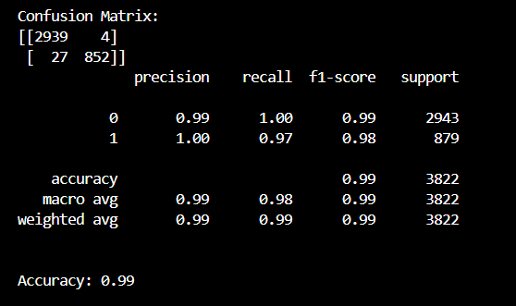

The Random Forest model performed exceptionally well in predicting employee turnover, achieving an **accuracy of 99%**. The confusion matrix shows **2939 true negatives**, **852 true positives**, only **27 false negatives**, and **4 false positives**. The model’s precision for predicting employees who left (1) is **100%**, while recall is **97%**, indicating its strong ability to identify at-risk employees accurately. The weighted F1-score of **0.99** further confirms its reliability across both classes. This high level of performance demonstrates the model's effectiveness in analyzing the complex relationships within the dataset.

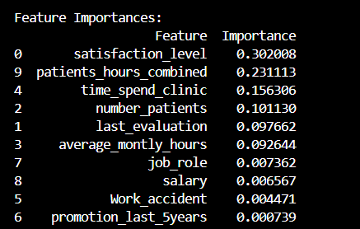Indications on Why Employees Are Leaving FAU Clinic:

The feature importance analysis highlights **low satisfaction levels** as the primary driver of turnover, with an importance score of **0.302**. Employees with dissatisfaction are likely to leave due to unmet expectations, poor recognition, or lack of work-life balance. The **patients-hours combined** metric (**0.231**) reveals that excessive workloads significantly contribute to stress and burnout. **Short tenure** (time spent in the clinic, **0.156**) is another critical factor, suggesting newer employees are more prone to leaving due to weaker organizational attachment or unfulfilled initial expectations.

Additional contributing factors include **high patient volumes** and **long working hours**, which exacerbate workload-related stress. While features like **salary**, **job role**, and **promotions** have minimal direct impact, addressing them could enhance overall retention efforts. These findings point to dissatisfaction, burnout, and inadequate early engagement as the primary reasons employees leave FAU Clinic.

After analyzing the data I can say that to retain the employees, FAU Clinic should prioritize improving **job satisfaction** by implementing regular surveys, recognition programs and addressing performance feedback or clarity. Managing workloads through monitoring metrics like **patients-hours combined** and redistributing tasks can help prevent burnout. Additionally, utilizing the model to identify at-risk employees will allow for targeted interventions to further reduce turnover rates.

Here is the summury of the report:

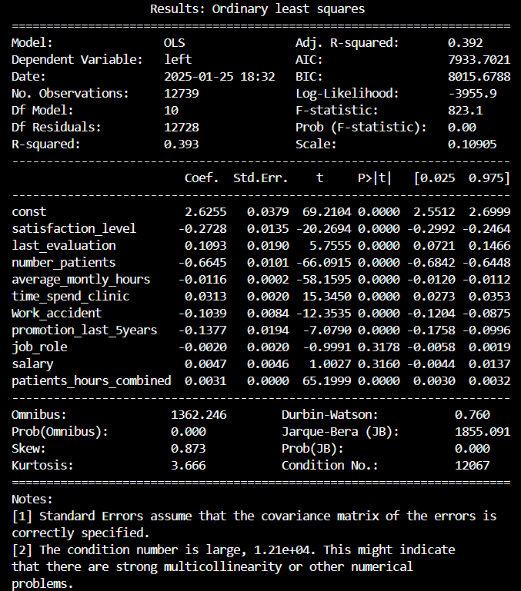

# References

1. *International Labour Organization (ILO). 1999-2022. Workplace well-being.*
2. *Meister, Jeanne. (2021). The Future Of Work Is Employee Well-Being.*
3. *Zheng, C., Molineux, J., Mirshekary, S., & Scarparo, S. (2015). Developing individual and organisational work-life balance strategies to improve employee health and wellbeing. Employee Relations, 37, 354-379.*
4. *Laulié, L., & Morgeson, F. P. (2021). The end is just the beginning: Turnover events and their impact on those who remain. Personnel Psychology, 74(3), 387-409.* [*https://doi.org/10.1111/peps.12422*](https://doi.org/10.1111/peps.12422)
5. *Mitchell, T. R., & Lee, T. W. (2001). 5. The unfolding model of voluntary turnover and job embeddedness: Foundations for a comprehensive theory of attachment. Research in Organizational Behavior, 23, 189- 246.*
6. *Beaudry, A., & Pinsonneault, A. (2005): Understanding user responses to information technology: A coping model of user adaptation. MIS Quarterly, 29(3), 493–524.*
7. *Joseph, D., Ng, K.-Y., Koh, C., & Ang, S. (2007). Turnover of information technology professionals: A narrative review, meta-analytic structural equation modeling, and model development. MIS Quarterly, 547-577*

# Declaration of Academic Integrity at the Schöller Endowed Chair for Information Systems

I hereby certify that I have prepared the submitted work independently, and without the unauthorized assistance of third parties, as well as without the use of unauthorized aids. The work has not been submitted in the same or similar form to any other examination authority, nor has it been accepted by any other examination authority as part of an examination.

The passages in the work, which have been taken from other sources in terms of wording or meaning, are identified by indicating the origin. This also applies to drawings, sketches, picture representations and sources from the Internet.

I am aware that the use of artificial intelligence is permitted for work at the Schöller Endowed Chair of Information Systems, Digitalization in Business and Society (esp. to improve the text written by myself). However, the intellectual core of the respective work has been developed by me, and the scientific methods that are part of the work have been carried out by myself. Furthermore, I have transparently communicated the aids used in the work.

Violations of the above-mentioned rules are to be qualified as deception or attempted deception and lead to an assessment of the examination with "failed". Further sanctions are possible in the case of multiple or particularly drastic violations of the rules by the examination board.

____________________________

Md Abdullah Al Mahmud Khosru Erlangen, 2025-01-26